EG2310 AY 21/22

Studio 2 Group 2

**Bill of Materials / CG derivation,**

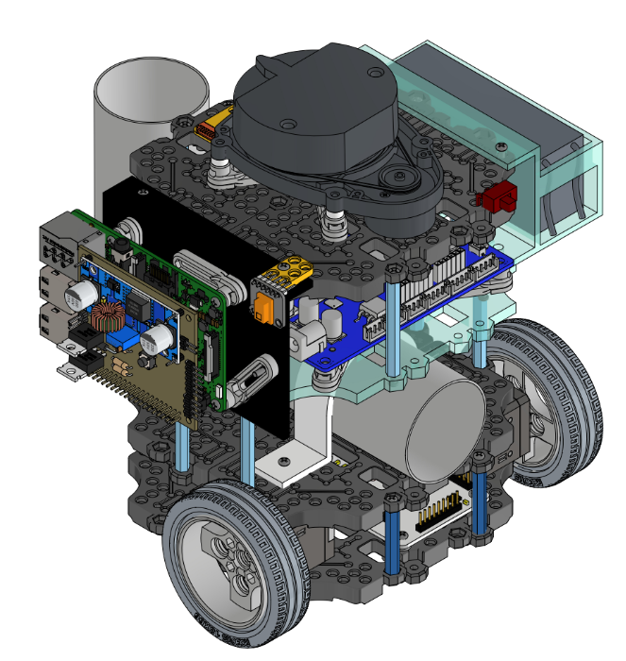**Tánkyu 2310i**

| Ang Kai Jun | A0235198W |
| --- | --- |
| David Chong Joon Wei | A0236533H |
| Ha Zhe Li | A0236541J |
| Rayner Lim Fang Yuh | A0238285W |
| Wang Yanxiao Austin | A0240524R |

# 

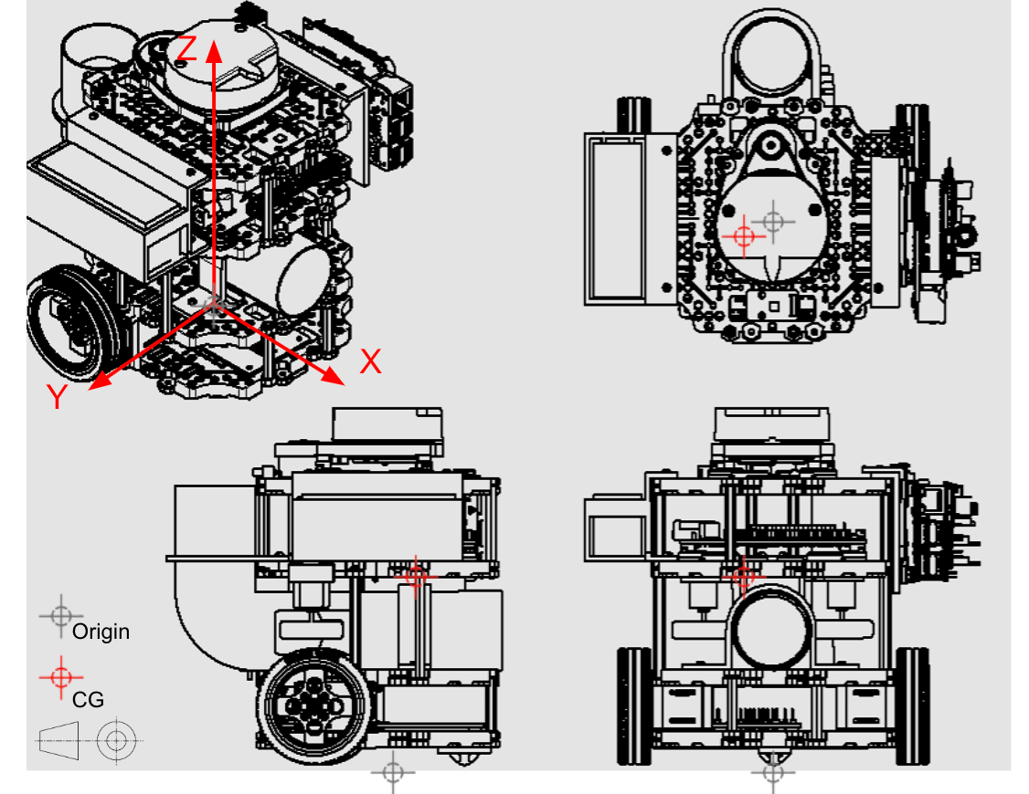

To find the CG, we first measure the XYZ coordinates of each component with respect to an arbitrary point on the robot. In this case we will set the reference on the ground level directly beneath the center of the waffle plate. This point will be our Origin.

Assumptions made:

1. All screws, nuts, bolts and washers’ CG are accounted for with the major component itself.
2. Parts symmetrical about the origin are assumed to have CG within the axis Z of the origin.

*Table 1: Bill of Materials*

Calculated to 3 Decimal Places.

| S/n. | Component | Weight  (Kg) | Component’s CG from origin | | |
| --- | --- | --- | --- | --- | --- |
| X(m) | Y(m) | Z(m) |
| **Level 1** | | | | | |
| 1.1 | Waffle Plate lvl 1 | 0.079 | 0.000 | 0.000 | 0.015 |
| 1.2 | Ball Caster | 0.004 | -0.005 | 0.000 | 0.000 |
| 1.3 | Left Dynamixel Motor | 0.055 | 0.040 | -0.05 | 0.020 |
| 1.4 | Right Dynamixel Motor | 0.055 | 0.040 | 0.050 | 0.020 |
| 1.5 | NFC reader | 0.016 | 0.005 | 0.010 | 0.016 |
| 1.6 | Posts x4 | 0.001 | 0.000 | 0.000 | 0.035 |
| 1.7 | Left Wheel + Tire | 0.029 | 0.040 | 0.080 | 0.030 |
| 1.8 | Right Wheel + Tire | 0.029 | 0.040 | -0.080 | 0.030 |
| **Level 2** | | | | | |
| 2.1 | Waffle Plate lvl 2 | 0.079 | 0.000 | 0.000 | 0.052 |
| 2.2 | Pipe clamp | 0.070 | 0.022 | 0.005 | 0.075 |
| 2.3 | Pipe | 0.120 | 0.090 | 0.005 | 0.100 |
| 2.4 | Servo mount | 0.002 | -0.037 | -0.050 | 0.063 |
| 2.5 | Servo | 0.010 | -0.035 | -0.030 | 0.065 |
| 2.6 | Posts x4 | 0.010 | 0.000 | 0.000 | 0.082 |
| **Level 3** | | | | | |
| 3.1 | Acrylic Waffle Plate lvl 3 | 0.079 | 0.010 | 0.000 | 0.112 |
| 3.2 | OpenCR bracket x4 | 0.007 | 0.020 | 0.000 | 0.120 |
| 3.3 | OpenCR | 0.062 | 0.020 | 0.000 | 0.125 |
| 3.4 | Motor mount x2 | 0.020 | -0.015 | 0.000 | 0.107 |
| 3.5 | Motor + wheel x2 | 0.034 | -0.030 | 0.000 | 0.107 |
| 3.6 | Posts x4 | 0.080 | -0.028 | 0.000 | 0.140 |
| **Level 4** | | | | | |
| 4.1 | Waffle Plate lvl 4 | 0.079 | 0.000 | 0.000 | 0.163 |
| 4.2 | Lidar bracket x4 | 0.007 | 0.000 | 0.000 | 0.178 |
| 4.3 | Lidar | 0.110 | -0.010 | 0.000 | 0.190 |
| 4.4 | USB2LDS | 0.002 | -0.052 | 0.000 | 0.178 |
| 4.5 | Rpi Bracket | 0.070 | 0.000 | 0.070 | 0.135 |
| 4.6 | Rpi support x4 | 0.007 | 0.015 | 0.085 | 0.127 |
| 4.7 | Rpi | 0.047 | 0.000 | 0.090 | 0.122 |
| 4.8 | PCB | 0.070 | 0.000 | 0.095 | 0.122 |
| 4.9 | IR sensor | 0.004 | 0.033 | 0.085 | 0.165 |
| 4.11 | IR bracket | 0.002 | 0.033 | 0.083 | 0.165 |
| 4.12 | Battery bracket | 0.070 | 0.000 | -0.093 | 0.145 |
| 4.13 | Battery | 0.137 | 0.000 | -0.095 | 0.137 |
| **TOTAL MASS:** | | 1.384kg | - | - | - |

Table 2: Moment of components

Calculated to 3 Significant Figures.

| **Component** | **Xm(kgm)** | **Ym(kgm)** | **Zm(kgm)** |
| --- | --- | --- | --- |
| **Level 1** | | | |
| Waffle Plate lvl 1 | 0.000 | 0.000 | 0.00119 |
| Ball Caster | -0.0000200 | 0.000 | 0.000 |
| Left Dynamixel Motor | 0.00220 | -0.00275 | 0.00110 |
| Right Dynamixel Motor | 0.00220 | 0.00275 | 0.00110 |
| NFC reader | 0.0000800 | 0.000160 | 0.000256 |
| Posts x4 | 0.000 | 0.000 | 0.0000350 |
| Left Wheel + Tire | 0.00116 | 0.00232 | 0.000870 |
| Right Wheel + Tire | 0.00116 | -0.00232 | 0.000870 |
| **Level 2** | | | |
| Waffle Plate lvl 2 | 0.000 | 0.000 | 0.00410 |
| Pipe clamp | 0.00154 | 0.000350 | 0.00525 |
| Pipe | 0.0108 | 0.000600 | 0.0120 |
| Servo mount | 0.0000740 | 0.0001000 | 0.000126 |
| Servo | -0.00035 | -0.000300 | 0.000650 |
| Posts x4 | 0.000 | 0.000 | 0.00082 |
| **Level 3** | | | |
| Acrylic Waffle Plate lvl 3 | 0.000790 | 0.000 | 0.00885 |
| OpenCR bracket x4 | 0.000140 | 0.000 | 0.000840 |
| OpenCR | 0.00124 | 0.000 | 0.00775 |
| Motor mount x2 | 0.000300 | 0.000 | 0.00214 |
| Motor + wheel x2 | -0.00102 | 0.000 | 0.00364 |
| Posts x4 | -0.00224 | 0.000 | 0.0112 |
| **Level 4** | | | |
| Waffle Plate lvl 4 | 0.000 | 0.000 | 0.0129 |
| Lidar bracket x4 | 0.000 | 0.000 | 0.00125 |
| Lidar | -0.00110 | 0.000 | 0.0209 |
| USB2LDS | -0.000104 | 0.000 | 0.000356 |
| Rpi Bracket | 0.000 | 0.00490 | 0.00945 |
| Rpi support | 0.000420 | 0.00238 | 0.00356 |
| Rpi | 0.00 | 0.00423 | 0.00573 |
| PCB | 0.00 | 0.00665 | 0.00854 |
| IR sensor | 0.000132 | 0.000340 | 0.000660 |
| IR bracket | 0.0000660 | 0.000166 | 0.000330 |
| Battery bracket | 0.000 | 0.00651 | 0.0102 |
| Battery | 0.000 | 0.0130 | 0.0188 |
| **TOTAL:** | 0.0175 | 0.0391 | 0.155 |

The overall CG position can therefore be calculated by summing the individual component moments in each axis and dividing that sum by the sum of mass of all the components.

| Sum Xm(kgm) | Sum Ym(kgm) | Sum Zm(kgm) |
| --- | --- | --- |
| 0.0175 | 0.0391 | 0.155 |

Total mass = 1.384kg

CG coordinates:

| X-distance(m) | Y distance(m) | Z distance (m) |
| --- | --- | --- |
| 0.0126 | 0.0283 | 0.112 |